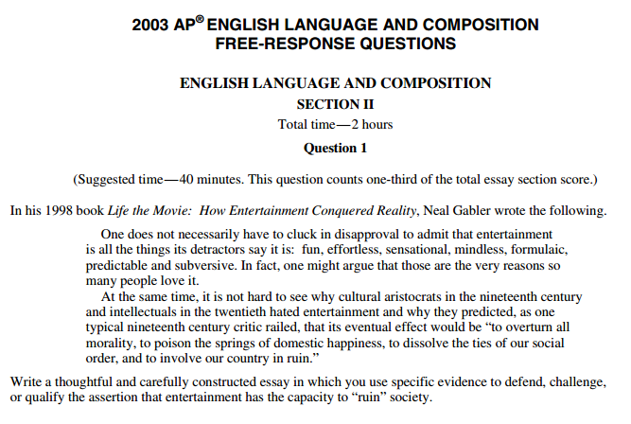1 http://tinyurl.com/zyn4d6s

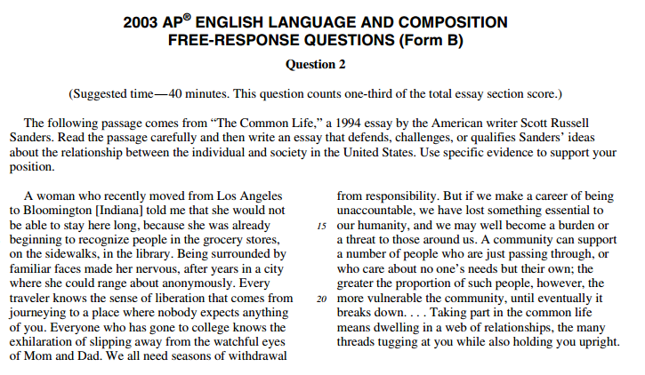2 http://tinyurl.com/zyn4d6s

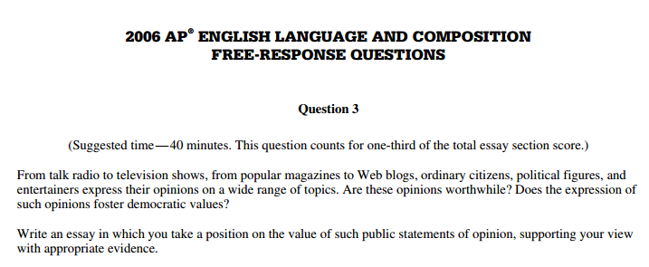3 http://tinyurl.com/zyn4d6s

4 http://tinyurl.com/zyn4d6s

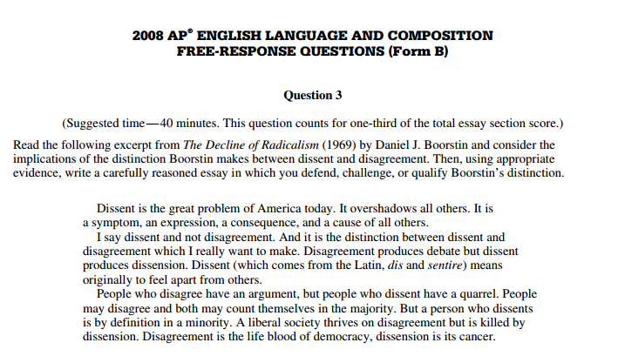5 http://tinyurl.com/zyn4d6s

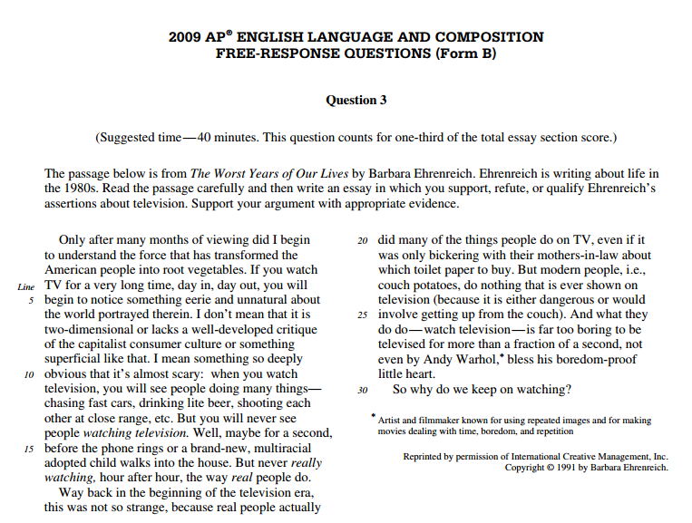6 http://tinyurl.com/zyn4d6s

7 http://tinyurl.com/zyn4d6s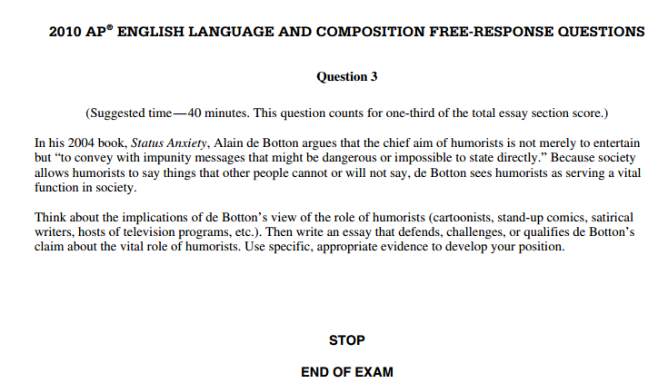8 http://tinyurl.com/zyn4d6s
http://tinyurl.com/zyn4d6s

